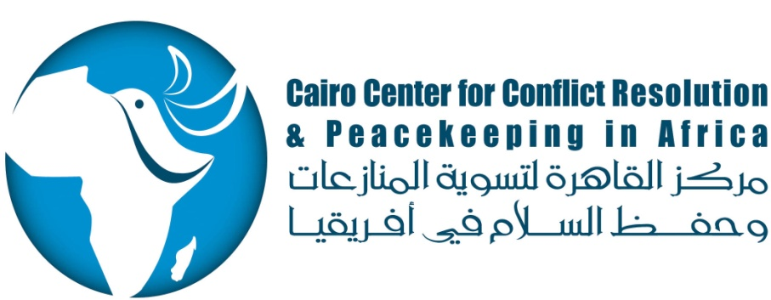
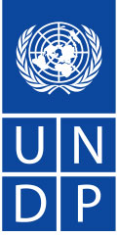
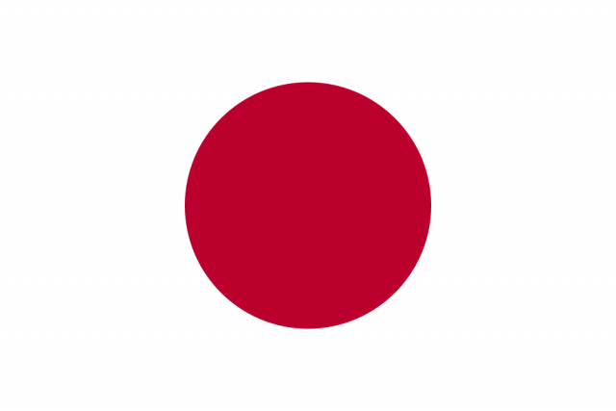

Award ID: 00080290-CCCPA Phase II
Enhancing the Capacity of Local Actors in Efforts to Improve Peace and Stability in North Africa, the Sahel and Great Lakes

Fourth Quarterly Report
1 December 2014 – 28 February 2015

Table of Content

Overview: 3
Background 5
1. Project Issues 6
2. Project Performance 6
2.1.0 OUTPUT 1: Improved Knowledge in Border Management in North Africa and the Sahel 6
2.1.1 Activity ID: Activity Result 1-1: Developed training methodology, curricula and partnerships 6
2.1.2 Activity ID: Activity Result 1-2: Trainings/workshops 8
2.1.3 Activity ID: Activity Result 1-3: Operational platform and mechanism to evaluate, follow-up and outreach with training alumni 16
2.2.0 OUTPUT 2: Greater Understanding of, and Improved Skills in, Peacekeeping and Peacebuilding Issues in North Africa, the Sahel and Great Lakes 18
2.2.1 Activity ID: Activity Result 2-1: Development of training methodology, curricula and partnerships 18
2.2.2 Activity ID: Activity Result 2-2: Training programs &workshops in the following areas: 20
2.2.3 Activity ID: Activity Result 2-3: Operational platform and mechanism to evaluate, follow-up and outreach with training alumni 24
2.3.0 OUTPUT 3: Improved Knowledge and Skills in Conflict Resolution and Crisis Management in North Africa, the Sahel and Great Lakes 25
2.3.1 Activity ID: Activity Result 3-1: Development of training methodology, curricula and partnerships 25
2.3.2 Activity ID: Activity Result 3-2: Training programs & workshops 26
2.3.3 Activity ID: Activity Result 3-3: Operational platform and mechanism to evaluate, follow-up and outreach with training alumni 31
2.4.0 OUTPUT 4: Establishment and Operation of a Project Management Unit 32
2.4.1 Activity ID: Activity Result 4-1: Project Management Unit is Established 32
2.4.2 Activity ID: Activity Result 4-2: Strengthened CCCPA M&E and Communication 33
2.4.3 Activity ID: Activity Result 4-3: CCCPA Advisory Board Meeting is Held 34
3.0 Financial Situation: 35

Overview:
The Cairo Center for Conflict Prevention and Peacekeeping in Africa (CCCPA or the Center) continues to gain exposure and credibility in its fourth quarter following its successes with the various activities it hosted in the past. The most significant activity is the request by the United Nations for CCCPA to host the UN Senior Mission Leaders training course (UNSML). The objective of the UNSML is to identify and prepare newly appointed and future mission leaders of UN peacekeeping operations and to familiarize them with their roles and responsibilities in peacekeeping operations. The Cairo UNSML course will bring together 50 people, including participants from a wide range of countries, UN officials, senior mentors, facilitators and presenters.

The decision to host the UN SML course in Cairo, for the first time, comes after months of discussions between the UN DPKO, CCCPA and the Permanent Mission of Egypt to the UN in New York. The opportunity to host this esteemed course is partly a recognition of Egypt’s leading role in peacekeeping in Africa and beyond.

In order to accommodate this important event, CCCPA has requested approval from the Government of Japan for a no-cost extension of the project until the end of June 2015 (the UNSML is a two-week training that is planned for the end of May to the beginning of June 2015). The approval has been granted to CCCPA during its fourth quarter and a shuffling of the remaining activities has been made accordingly to allocate funds to the UNSML. It has now been decided that the workshop on border management issues will be cancelled and the funds for the remaining workshop in peacekeeping and peacebuilding will be reserved for the UNSML.

The fourth quarter also marked a record high in pre-deployment participation in trainings on peacekeeping and peacebuilding for Egyptian military officers about to be deployed to the Democratic Republic of the Congo and the Central African Republic. A total of 1,250 officers/NCO/personnel were trained in a timeframe of two weeks. These trainings demonstrate the ability of the CCCPA to provide expertise in the topics of peacekeeping and peacebuilding in very short notice and to a wide participant base. It also exhibits the military’s reliability on CCCPA to provide these important trainings at a quick turnaround.

CCCPA also made use of its partnership with USIP to build the capacity of its staff in the area of Project Management Cycles. A full week was dedicated to the CCCPA team to train them on topics such as proposal writing, training design and M&E tools. A second training was also provided to the entire staff during the fourth quarter, on peacekeeping and peacebuilding.

Activity | Q1 | Q2 | Q3 | Q4 | Total to date | Project target | Percentage of achievement
 | (Mar-May) | (Jun-Aug) | (Sep-Nov) | (Dec’14-Feb ‘15
Output (1) Improved knowledge in border management in North Africa and the Sahel
Number of participants trained on border management | 0 | 18 | 83 | 90 | 191 | 300 | 64%
Number of trainings organized on border management topics | 0 | 1 | 4 | 4 | 9 | 12 | 75%
Number of workshops organized on border management topics | 0 | 0 | 0 | 0 | 0 | 1 | 0
Knowledge gained by participants | 0 | 100% | 100% | 100% | 100% | 70% | 100%
Output (2) Greater understanding of, and improved skills, in peacekeeping and peacebuilding issues in North Africa, the Sahel and Great Lakes region
Number of participants trained on peacekeeping and peacebuilding | 19 | 0 | 66 | 1,273 | 1,358 | 200 | 679%
Number of trainings organized on peacekeeping and peacebuilding topics | 1 | 0 | 3 | 4 | 8 | 8 | 100%
Number of workshops organized on peacekeeping and peacebuilding topics | 0 | 0 | 3 | 0 | 3 | 4 | 75%
Knowledge gained by participants | 100% | 0 | 100% | 100% | 0 | 70% | 100%
Output (3) Improved knowledge and skills in conflict resolution and crisis management in North Africa, the Sahel and Great Lakes region
Number of participants trained on conflict resolution and crisis management | 0 | 70 | 145 | 41 | 256 | 300 | 85%
Number of trainings organized on conflict resolution and crisis management topics | 0 | 3 | 5 | 2 | 10 | 12 | 72%
Knowledge gained by participants | 0 | 100% | 100% | 100% | 100% | 70% | 100%
Number of research papers published on conflict resolution and crisis management topics | 0 | 0 | 0 | 0 | 0 | 2 | 0%
Output 4: Project Management Unit is established and operational
Number of PMU team recruited | 3 | 0 | 0 | 0 | 3 | 3 | 100%
All PMU staff trained on monitoring and evaluation | 3 | 0 | 0 | 0 | 3 | 3 | 100%
Quarterly progress reports prepared and submitted to UNDP by PMU | 1 | 1 | 1 | 1 | 4 | 4 | 100%
Project M&E plan finalized | 1 | 0 | 0 | 0 | 1 | 1 | 100%
Project board meeting organized and held by PMU | 0 | 0 | 0 | 0 | 0 | 1 | 0%

Background
EMFA established the Cairo Center for Conflict Resolution and Peacekeeping in Africa in 1994, in line with Egypt’s sense of responsibility towards achieving peace and security in Africa, including building African capacities. In recognition of its contribution to African peace and security, the Center is now among a few centers on the continent recognized by the AU as ‘Centers of Excellence in Training in Peacekeeping’.

Despite the huge efforts of the international community, Africa continues to be conflict-ridden, with devastating consequences on human security and serious repercussions for global peace. Facing such challenges requires the cooperation of countries in these regions that are pillars of security and stability, such as Egypt, and leading global powers, such as Japan.

From 2008 to 2013, CCCPA received support from GoJ through theUNDP; the support was critical in strengthening the Center’s institutional capacity and improving its ability to contributing to building the capacities of other African local actors in areas of peacebuilding and peacekeeping. In May 2014, this collaboration entered a new phase with the signing of the project “Enhancing the Capacity of Local Actors in Efforts to Improve Peace and Stability in North Africa, the Sahel and Great Lakes” (hereafter referred to as “the Project”) to achieve the following:

- Expand the scope and maximize the impact/visibility of the trainings to ensure that capacities have the necessary skills for appropriate and timely responses to incidents that threaten peace and stability [Training courses include (i) Building/Enhancing the Capacities of African Regional, National and Local Actors in Areas of Border Management; (ii) Peacekeeping and Peacebuilding; and (iii) Conflict Resolution and Crisis Management]
- Respond to traditional and emerging threats to the different aspects of security in Africa - such as the Ebola outbreak in Western Africa
- Improve the quality of the training experience - including partnering with world-class expertise

As outlined in the Project’s document, the expected outputs are:

- Improved knowledge in border management in North Africa and the Sahel – Output no.1
- Greater understanding of, and improved skills in, peacekeeping and peacebuilding issues in North Africa, the Sahel and Great Lakes – Output no.2
- Improved knowledge and skills in conflict resolution and crisis management in North Africa, the Sahel and Great Lakes – Output no.3
- Establishment and operation of a Project Management Unit – Output no. 4

This report presents the main activities of the Project during the period from 1 December 2014 to28 February 2015.

1. Project Issues
Updated Project Risks  The Center faced the possible risk of low turnouts due to a number of religious and national holidays falling during this quarter.  Nevertheless, as a result of thorough planning, this risk was averted, thereby successfully limiting the number of cancellations and late arrivals to a minimum. | Updated Project Issues  Following its success with hosting severalhigh- level workshops and training courses in cooperation with theUN and AU, CCCPA has been selected as the preferred partner to host the UN Senior Mission Leaders training and the AU’s African Standby Force 7th Annual Training Implementation Workshop in May and June 2015.

2. Project Performance

2.1.0 OUTPUT 1: Improved Knowledge in Border Management in North Africa and the Sahel

Deliverable Description

During this period, CCCPA successfully conducted fourtraining courses under Output 1:
- Onetraining on “Combating Human Trafficking” was held at the Conrad Hotel from 1-4 December 2014.
- Threetrainings on“Illicit Transfer of Small Arms and Light Weapons”. The first and second trainings were held from 15-18 December 2014 and 12-15 January 2015 at the InterContinental Cairo Semiramis while the third was held from 26-29 January 2015 at the Conrad Hotel.

A total of 90 participantsfrom 12 countries, and different professional affiliations, participated in these trainings.

The Center also began preparations for upcoming training courses on border issues during this period.

Target: March 2014 – February 2015

Achievement from1 December 2014-28 February 2015

2.1.1 Activity ID: Activity Result 1-1: Developed training methodology, curricula and partnerships

Deliverable Description

During this quarter, CCCPA continued the recruitment process for consultantsand researchers to assist with the technical training programs and curriculum development.Additionally, CCCPA coordinated withboth IOM and SAS to conduct the training courses.

Indicators

- Number of technical staff recruited
During this quarter, CCCPA advertised for the position of Technical Advisor to support activities related to border management. One candidate was a potential for the vacancy thanks to his vast knowledge on human trafficking and his experience in creating training manuals.

- Number of coordination meetings with counterparts conducted
CCCPA cooperated with SAS on two joint training courses for peacekeepers on the illicit transfer of SALW.(SAS is an independent research project at theGraduate Institute of International and Development Studies in Geneva, Switzerland. It serves as the principal international source of public information on all aspects of small arms and armed violence and as a resource for governments, policy-makers, researchers, and activists. The project has an international staff with expertise in security studies, political science, international public policy, law, economics, development studies, conflict resolution, criminology, and sociology.)

- Number of research areas identified
This indicator was achieved during Q1 of the Project (1 March – 31 May 2014).

- Number of appropriate implementing partners identified
CCCPA conducted two joint trainingswith SAS on the illicit transfer of SALW.

- Number of consultation workshops with implementing partners conducted
During this quarter, a training program on the ‘Project Management Cycle’ was held in cooperation with USIP to enhance the capacities of CCCPA staff.

- Number of briefing papers developed
Following the identification of the research areas related toborder management and human trafficking, a technical meeting was held to outline the research materials. One draft research material (training manual)was prepared in Arabic and piloted at the training on combating human trafficking held from 1-4 December 2014. The manual will be finalized and translated into English and French.

- Number of training/workshop programs designed
Contact was made with IOM to plan for the upcoming trainings on border issues scheduled for the next quarter (no-cost extension).

Current Evaluation
Start and End Date: March 2014- February 2015
Percentage progress to date: 75%
1-1
Quality Criteria |  | Date |  | Results of Activities
 |  |  |  | User Perspective |  | Resource Status |  | Timeliness
Financial Summary - in USD
Account | Fund | Donor | R. Party |  | Budget | Expenditure | Balance
 | GoJ | GoJ |  |  | 93,061.51 |  | 76,261.79
71405 | 26960 | 00141 |  |  |  | 4,474.90
71810 | 26960 | 00141 |  |  |  | 5,430.03
74598 | 26960 | 00141 |  |  |  | 1,305.68
71605 | 26960 | 00141 |  |  |  | 1,951.75
71615 | 26960 | 00141 |  |  |  | 688
64398 | 26960 | 00141 |  |  |  | 3,046.58
76135 | 26960 | 00141 |  |  |  | -97.22

2.1.2 Activity ID: Activity Result 1-2: Trainings/workshops

Trainings and workshops are to be held in the following areas:
- Border Management Mechanisms
- Illicit Transfer of Small Arms and Light Weapons
- Human Trafficking

Deliverable Description

Four training courses were conducted: one training course was conducted on “Combating Human Trafficking”and three training courses were conducted on “Illicit Transfer of Small Arms and Light Weapons”, two of which were in cooperation with Small Arms Survey.

The Trainings

Combating Human Trafficking 1-4 December 2014

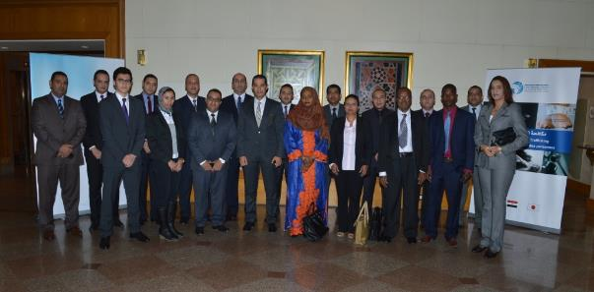
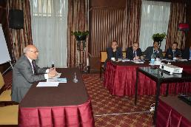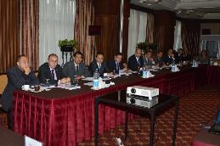
Indicators
- Number of participants trained (country and gender disaggregated)

Total Participants | Male | Female
22 | 18 | 4

Affiliation | Total
Military | 6
Police | 6
Justice | 5
Foreign Affairs | 5
Total | 22

Country | Total
Chad | 2
Comoros | 1
Djibouti | 2
Egypt | 14
Morocco | 1
Sudan | 2
Total | 22

Illicit Transfer of Small Arms and Light Weapons15-18 December 2014

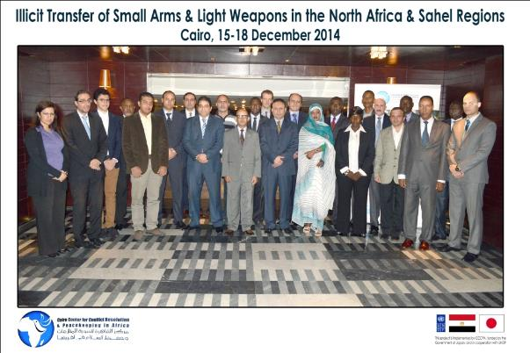

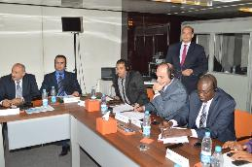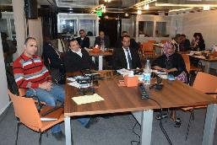

Indicators
- Number of participants trained (country and gender disaggregated)
Total Participants | Male | Female
20 | 18 | 2

Affiliation | No. of participants
Military | 4
Police | 8
Foreign Affairs | 8
Total | 20

Country | No. of participants
Chad | 2
Egypt | 8
Mali | 2
Mauritania | 2
Morocco | 2
South Sudan | 2
Sudan | 2
Total | 20

Illicit Transfer of Small Arms and Light Weapons12-15 January, 2015
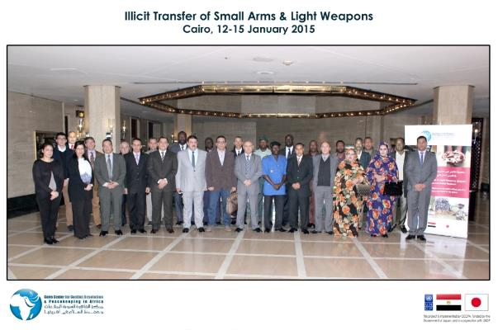

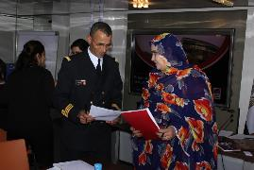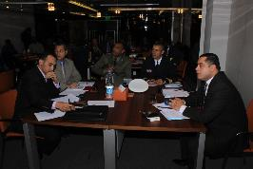

Indicators
Number of participants trained (country and gender disaggregated)
Total Participants | Male | Female
25 | 23 | 2

Affiliation | Total
Military | 5
Police | 13
Foreign Affairs | 7
Total | 25

Country | Total
Algeria | 1
Chad | 2
Egypt | 8
Mali | 3
Mauritania | 3
Morocco | 2
Tunisia | 2
Sudan | 4
Total | 25

Illicit Transfer of Small Arms and Light Weapons26-29 January, 2015
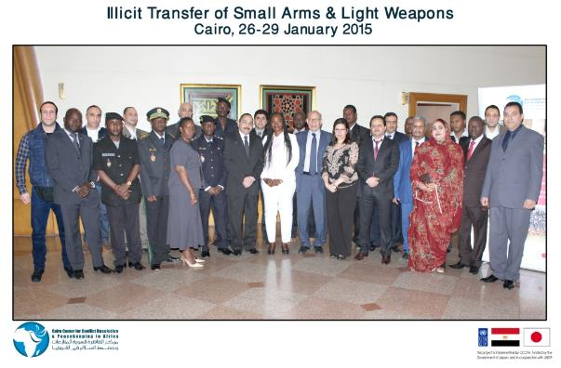

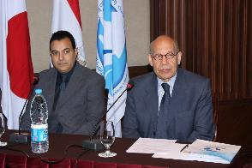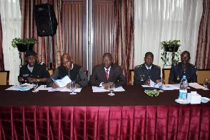

Indicators
- Number of participants trained (country and gender disaggregated)
Total Participants | Male | Female
23 | 20 | 3

Affiliation | Total
Military | 4
Police | 15
Foreign Affairs | 4
Total | 23

Country | Total
Egypt | 7
Mali | 4
Mauritania | 2
Morocco | 2
Niger | 6
Sudan | 2
Total | 23

Current evaluation
Start and End Date: March 2014- February 2015
Percentage progress to date: Approximately 75% (total progress to date - 9 trainings out of 12)
1-2
Quality Criteria |  | Date | Results of Activities
 |  |  | User Perspective |  | Resource Status | Timeliness
Financial Summary - in USD
Account | Fund | Donor | R. Party | Budget | Expenditure | Balance
 | GoJ | GoJ |  | 353,129.22 |  | 143,659.29
71605 | 26960 | 00141 |  |  | 79,759.05
71615 | 26960 | 00141 |  |  | 22,799.19
71305 | 26960 | 00141 |  |  | 14,273.28
72410 | 26960 | 00141 |  |  | 126.1
72505 | 26960 | 00141 |  |  | 599.89
72510 | 26960 | 00141 |  |  | 1,754.30
72120 | 26960 | 00141 |  |  | 67,693.19
72130 | 26960 | 00141 |  |  | 3,539.38
73105 | 26960 | 00141 |  |  | 10,647.29
73405 | 26960 | 00141 |  |  | 8,991.75
74210 | 26960 | 00141 |  |  | 481.44
75712 | 26960 | 00141 |  |  | 3,933.86
76135 |  |  |  |  | - 5,128.79

2.1.3 Activity ID: Activity Result 1-3: Operational platform and mechanism to evaluate, follow-up and outreach with training alumni

Indicators
- Database of participants developed
This indicator was achieved during Q1 of the Project.

- Monitoring and evaluation mechanisms developed
This indicator was achievedduring Q1 of the Project.

- Knowledge gained by participants as measured

Participants Perception Questionnaire (Level 1)

“Combating Human Trafficking”,1 – 4 December 2014
Scale:5=Strongly Agree 4=Agree for the Most Part 3=Somewhat Agree 2=Agree Only Slightly 1=Disagree
Evaluation | Rating (Average)
Course Objectives & Content | 4.5
Training Materials | 4.4
Trainers’ Skills | 4.5
Course Administration | 4.3
Accommodation and Training Room | 4.3

“Illicit Transfer of Small Arms and Light Weapons”, 15-18 December 2014
“I gained a lot of information about SALW, the threats they pose, their effects on development and the need to enhance the legal framework and the international cooperation” Participant from the SALW course 15-18 December 2014
Scale:5=Strongly Agree 4=Agree for the Most Part 3=Somewhat Agree 2=Agree Only Slightly 1=Disagree
Evaluation | Rating (Average)
Course Objectives & Content | 4.2
Training Materials | 4.4
Trainers’ Skills | 4.3
Course Administration | 3.8
Accommodation and Training Room | 4.6

“Illicit Transfer of Small Arms and Light Weapons”, 12-15 January 2015
Scale:5=Strongly Agree 4=Agree for the Most Part 3=Somewhat Agree 2=Agree Only Slightly 1=Disagree
Evaluation | Rating (Average)
Course Objectives & Content | 4.4
Training Materials | 4.2
Trainer Skills | 4.3
Course Administration | 4.1
Accommodation and Training Room | 3.9

“Illicit Transfer of Small Arms and Light Weapons”, 26-29 January 2015
Scale:5=Strongly Agree 4=Agree for the Most Part 3=Somewhat Agree 2=Agree Only Slightly 1=Disagree

Evaluation | Rating (Average)
Course Objectives & Content | 4.2
Training Materials | 4.0
Trainers’ Skills | 4.0
Course Administration | 4.0
Accommodation and Training Room | 4.3

Follow-up group with available participants and partners to assess impact conducted
Implementation was not scheduled during Q4 of the Project.

Current evaluation
Start and End Date: March 2014- February 2015
Percentageprogress to date: 75%
1-3
Quality Criteria |  | Date |  | Results of Activities
 |  |  |  | User Perspective |  | Resource Status |  | Timeliness
Financial Summary– in USD
Account | Fund | Donor | R. Party |  | Budget |  | Expenditure | Balance
 | GoJ | GoJ |  |  | 15,000.00 |  |  | 15,000.00
71405 | 26960 | 00141 |  |  |  |  | 0.00

2.2.0 OUTPUT 2: Greater Understanding of, and Improved Skills in, Peacekeeping and Peacebuilding Issues in North Africa, the Sahel and Great Lakes

Deliverable Description
During this period, CCCPA successfully conducted three training courses under Output 2:
- Onetraining for AMISOM on“Gender, International Humanitarian Law (IHL) and Human Rights (HR) in Peacekeeping and Peacebuilding”- held at theRamsis Hilton Hotel from 14 to 18 December 2014
- Twotraining courseson “Pre-deployment Training for Egyptian Military Police Deployed to DRC”- held from 31 December 2014 to 1 January 2015 and 10 to 13 January 2015 at the Egyptian military base.
- Onetraining course on “Pre-deployment Training for Egyptian Military Police Deployed to CAR”- held from 5 to 8January 2015 at the Egyptian military base.

A total of 1,273participants from 7 countries attended these trainings.

Target: March 2014 – February 2015
Achievement from1 December 2014 -28February 2015

2.2.1 Activity ID: Activity Result 2-1: Development of training methodology, curricula and partnerships

Deliverable Description

During this quarter, CCCPA continuedthe recruitment process for consultants and researchers to assist with the technical training programs and curriculum development. The CVs were screened, short-listed and relevant interviews were conducted. Additionally, CCCPA coordinated with PeaceCap Network, USIP, the UN and the AU to conduct training courses in the following quarter.

Indicators

- Number of technical staff recruited
One research officer was hiredin Q3.

- Number of research/situation analyses developed
During this quarter, CCCPAco-hostedan author's workshop in Cairo with PeaceCap Network, where the partners discussed the research themes for the national baseline studies on the role of Emerging Actors in Peace Operations, Security Sector Reform and Civilian Capacities. The outcome of the discussions will determine the collective research agenda for 2015-2016.

CCCPA also participated in the Annual Conference and AGM of the African Peace Support Trainers Association (APSTA) in the fourth quarter. New training initiatives andharmonization of training activities in Africa were among the topics discussed.

Finally, a meeting was held with the Delegation of the African Union Commission (AUC) to discuss the requirements for the African Capacity for Immediate Response “ACIRC”.

- Number of training/workshop programs designed
The High-level Independent Panel on Peace Operations will be visiting Cairo on 4-5 March for bilateral meetings with officials of national governments in the MENA region and regional organizations (the League of Arab States, Organization of Islamic Cooperation, Gulf Cooperation Council, and the African Union); and to engage Arab think tanks, academics and civil society organizations. This visit comes as part of the Panel’s assessment of the state of UN peace operations and the emerging needs of the future.On March 5, 2015 CCCPA will organize a full-day of consultations with Member State officials, regional organizations representatives, think tanks, and civil society. The consultations will be co-hosted by the High-Level Independent Panel and the Government of Egypt and will cover various issues on peace, conflict and the challenges of peacekeeping.

CCCPA will host the Cairo UNSML in May/June 2015. Coordination meetings have been planned with the UN, Egyptian Ministry of Foreign Affairs and CCCPA to further discuss the event.

CCCPA has also been approached by the African Union to request that CCCPA host the 7th African Standby Force (ASF) Training Implementation Workshop. This workshop will present the report of the Training Needs Analysis, harmonize and integrate ASF Trainingfor 2015, integrate activities for the Exercise AMANI AFRICA II and provide strategic training directives for the Regional Stand by Forces. Additionally, the workshop will review the Support to African Training Centre’s programme to enhance coordination between AUC and RECs/RMs ASF Training Officers and the development of pragmatic mechanisms for the use, accessing and reporting of funding. This activity will take place in May 2015.

- Number of research materials published
Following the identification of research areas related to conflict resolution and crisis management, a technical meeting was held to outline the research materials required. It was agreed that two research materialswere to be published covering “North Africa in Transition”.Furthermore, CCCPA and USIP discussed possible cooperation on research and publications, and accordingly a meeting was held in September 2014.

Current evaluation
Start and End Date: May 2014 – February 2015
Percentage progress to date: 75%
2-1
Quality Criteria |  |  | Date | Results of Activities
 |  |  |  | User Perspective |  | Resource | Timeliness
Financial Summary – in USD
Account | Fund | Donor | R. Party |  | Budget | Expenditure | Balance
 | GoJ | GoJ |  |  | 58,498.9 |  | 44,943.97
71405 | 26960 | 00141 |  |  |  | 4,055.38
71810 | 26960 | 00141 |  |  |  | 7,873.55
71615 | 26960 | 00141 |  |  |  | 1,626.00

2.2.2 Activity ID: Activity Result 2-2: Training programs &workshops in the following areas:

Trainings and workshops are to be held in the following areas:
- Human Rights
- Rule of Law
- Transitional Justice
- Transitional Issues

Deliverable Description

During this period, CCCPA successfully conducted four training courses: One “Gender, International Humanitarian Law (IHL) and Human Rights (HR) in Peacekeeping and Peacebuilding” coursefor AMISOM personnel and three“Pre-deployment Training on Peacekeeping &Peacebuilding” for Egyptian military officers deployed to the DRC and CAR.

The Training Courses

Gender, International Humanitarian Law (IHL) and Human Rights (HR) in Peacekeeping and Peacebuilding Training for AMISOM,14-18 December 2014

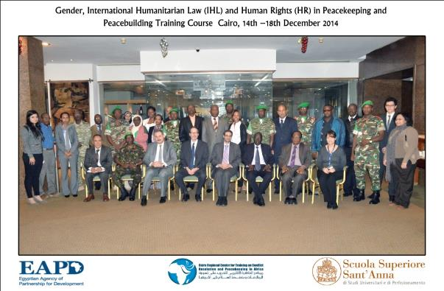

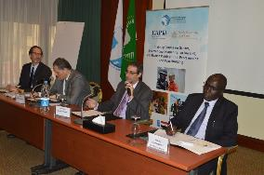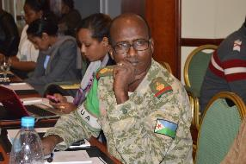

Indicators
- Number of participants trained (country and gender disaggregated)
Total Participants | Male | Female
23 | 18 | 5

Affiliation | Total
Military | 10
Police | 2
Civilian | 11
Total | 23

Country | Total
AU | 3
Burundi | 3
Cameroon | 1
Djibouti | 3
Egypt | 2
Ethiopia | 2
Kenya | 3
Sierra Leone | 2
Somalia | 2
Uganda | 2
Total | 23

Peacekeeping &Peacebuilding Pre-Deployment Training for Egyptian Military Officers Deployed to the DRC,31 December 2014-1 January 2015

Indicators
- Number of participants trained (country and gender disaggregated)
Total Participants | Male | Female
150 | 150 | 0

Participants were Egyptian military officers about to be deployed to a peacekeeping mission in the Democratic Republic of the Congo.

Peacekeeping &Peacebuilding Pre-Deployment Training for Egyptian Military Officers Deployed to the CAR,5-8 January 2015

Indicators
- Number of participants trained (country and gender disaggregated)

Total Participants | Male | Female
250 | 250 | 0

Participants were Egyptian military officers about to be deployed to a peacekeeping mission in the Central African Republic.

Peacekeeping &Peacebuilding Pre-Deployment Training for Egyptian Military Officers Deployed to the DRC,10-13 January 2015

Indicators
- Number of participants trained (country and gender disaggregated)
Total Participants | Male | Female
850 | 850 | 0

Participants were Egyptian military officers about to be deployed to a peacekeeping mission in the Democratic Republic of the Congo.

Current evaluation
Start and End Date: May 2014 – February 2015
Percentage progress to date: ApproximatelyAverage 92%(8 trainings courses out of 8; 3 workshops out of 4)
2-2
Quality Criteria |  |  | Date | Results of Activities
 |  |  |  | User Perspective |  | Resource Status |  | Timeliness
Financial Summary - USD
Account | Fund | Donor | R. Party |  | Budget |  | Expenditure | Balance
 | GoJ | GoJ |  |  | 295,058.67 |  |  | 142,827.92
71615 | 26960 | 00141 |  |  |  |  | 12,003.66
71605 | 26960 | 00141 |  |  |  |  | 21,529.96
74210 | 26960 | 00141 |  |  |  |  | 209.18
74525 | 26960 | 00141 |  |  |  |  | 8,495.00
72120 | 26960 | 00141 |  |  |  |  | 86,585.63
72130 | 26960 | 00141 |  |  |  |  | 1,275.69
72505 | 26960 | 00141 |  |  |  |  | 3,940.57
72515 | 26960 | 00141 |  |  |  |  | 8,436.03
71305 | 26960 | 00141 |  |  |  |  | 1,398.40
73105 | 26960 | 00141 |  |  |  |  | 1,384.42
76135 | 26960 | 00141 |  |  |  |  | -89.95
73405 | 26960 | 00141 |  |  |  |  | 7,061.95

2.2.3 Activity ID: Activity Result 2-3: Operational platform and mechanism to evaluate, follow-up and outreach with training alumni

Indicators
- Database of participants developed
This indicator was achieved during Q1 of the Project.

- Monitoring and evaluation mechanisms developed
This indicator was achieved during Q1 of the Project.

- Knowledge gained by participants as measured (end of course evaluation)
Participants have gained knowledge and skills in the various through these courses. Almost all participants think that these courses will assist them in their future work and that they will be able to use some of the new procedures learnt. Most of the participants demonstrate or perceive their improved knowledge.

Participant Perception Questionnaire (Level 1)

Gender, International Humanitarian Law (IHL) and Human Rights (HR) in Peacekeeping and Peacebuilding, 14-18 December 2014
Scale:5=Strongly Agree 4=Agree for the Most Part 3=Somewhat Agree 2=Agree Only Slightly 1=Disagree
Evaluation | Rating (Average)
Course Objectives & Content | 4.2
Training Materials | 3.9
Trainers’ Skills | 4.0
Course Administration | 4.1
Accommodation and Training Room | 4.6

Peacekeeping &Peacebuilding Pre-Deployment Training for Egyptian Military Officers Deployed to the DRC& CAR (31 December 2014 – 1 January 2015, 5-8 January 2015 & 10-13 January 2015)

Due to the large number of participants and the urgency to complete the training in time for their deployment, distribution of evaluations was not possible during the three pre-deployment trainings for Egyptian military officers.

- Follow-up group with available participants and partners to assess impact conducted
Implementation was not scheduled during Q4 of the Project.

Current evaluation
Start and End Date: May 2014 – February 2015
Percentage progressto date: 75%

Quality Criteria |  |  | Date | Results of Activities
 |  |  |  | User Perspective |  | Resource Status | Timeliness
Financial Summary – in USD
Account | Fund | Donor | R. Party |  | Budget | Expenditure | Balance
 | GoJ | GoJ |  |  | 20,000 |  | 20,000
 |  |  |  |  |  | 00.00

2.3.0 OUTPUT 3:Improved Knowledge and Skills in Conflict Resolution and Crisis Management in North Africa, the Sahel andGreat Lakes

Deliverable Description

During this period, CCCPA successfully conducted two training courses under Output 3:
Two training courseson“Conflict Analysis & Sensitivity”- held at the Fairmont Nile City Hotel in Cairo from 16-19 February 2015 and 23-26 February 2015.

A total of 41 participants from 15 countries and different organizations, attended the training.

Target: March 2014- February 2015
Achievement fromDecember 2014 –February 2015

2.3.1 Activity ID: Activity Result 3-1: Development of training methodology, curricula and partnerships

Deliverable Description

During this quarter, CCCPAcontinued the recruitment process for a program associate and consultants to assist with the technical training programs and curriculum development. The CVs were screened, short-listed and relevant interviews were conducted.

Indicators
- Number of technical staff recruited
During this quarter, CCCPA advertised for a call for proposal from potential consultants to assist with the four trainings on Conflict Analysis & Sensitivity. Several proposals were received and shortlisted; International Alert was selected and a contract was signed with them during this quarter.

A vacancy notice was also posted on the UNDP website for a replacement for the Program Associate under this output. Several CVs were received and filtered and a shortlist was created; a Program Associate was selected and hired during this quarter.

- Number of research/situation analyses developed
Consultation meetings were held with International Alert for the Training of Trainers in the topic of “Conflict Analysis & Sensitivity” scheduled for the next quarter. Discussions also included the possibility of certifying the course with Europe's New Training Initiative for Civilian Crisis Management (ENTRi) and the prospects of future cooperation in research-based activities between CCCPA and International Alert. (International Alert is one of the world’s leading peacebuildingorganisations, with nearly 30 years of experience laying the foundations for peace. They work with locals of over 25 countries from around the world to help them build peace, and advise governments, organisations and companies on how to support peace.)

- Number of training/workshop programs designed
Onemeeting was held with International Alertto plan the Training of Trainers course scheduled next quarter on “ConflictAnalysis & Sensitivity”.

- Number of research materials published
Two research materials were finalized and were expected to be published during this quarter: one coveringconflict management issues related to the implementation of DDR, and the other coveringthe role of media in reporting a crisis.

Current evaluation
Target : March 2014- February 2015
Percentage progressto date: 72 %
3-7
Quality Criteria |  | Date |  | Results of Activities
 |  |  |  | User Perspective |  | Resource Status | Timeliness
Financial Summary – in USD
Account | Fund | Donor | R. Party |  | Budget | Expenditure |  | Balance
 | GoJ | GoJ |  |  | 75,596.63 |  |  | 73,745.59
71405 | 26960 | 00141 |  |  |  | 629.28
71810 |  |  |  |  |  | 1,221.76

2.3.2 Activity ID: Activity Result 3-2: Training programs & workshops

Trainings and workshops are to be held in the following areas:
- Conflict Resolution
- Crisis Management

Deliverable Description

During this period, CCCPA successfully conducted two training courses on "Conflict Analysis & Sensitivity". The trainings targeted participants with backgrounds indiplomacy, research, academia, civil society and public service and covered topics such as conflict theories, stakeholder mapping, and impact assessment. The trainings were attendedby 41 participants from 15 countries.

Training Courses

Conflict Analysis & Sensitivity, 16-19 February 2015
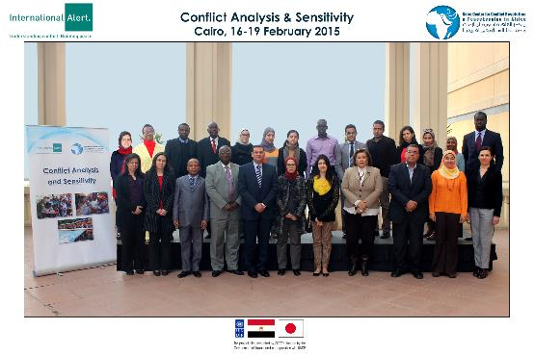
Indicators
- Number of participants trained (country and gender disaggregated)

Total Participants | Male | Female
19 | 7 | 12

Affiliation | Total
Foreign Affairs | 6
Research | 8
NGO | 5
Total | 19

Country | Total
Burundi | 1
Egypt | 13
Eritrea | 1
Kenya | 1
Senegal | 1
Tanzania | 1
Zambia | 1
Total | 19

Conflict Analysis & Sensitivity, 23-26 February 2015
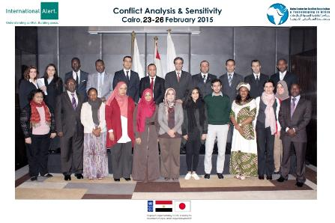
Indicators
- Number of participants trained (country and gender disaggregated)

Total Participants | Male | Female
22 | 17 | 4

Affiliation | Total
Military | 4
Foreign Affairs | 9
NGO | 3
Academia | 2
Training Center | 2
Research | 2
Total | 22

Country | Total
Algeria | 1
Chad | 1
Djibouti | 1
Egypt | 12
Gambia | 1
Morocco | 1
Nigeria | 1
Tunisia | 1
Uganda | 2
Zambia | 1
Total | 22

Start and End Date: March 2014 – February 2015
Percentage progressto date: Approximately 72% (10 training courses out of 12)
3-8
Quality Criteria |  |  | Date | Results of Activities
 |  |  |  | User Perspective |  | Resource Status |  |  | Timeliness
Financial Summary – in USD
Account | Fund | Donor | R. Party |  | Budget |  | Expenditure | Balance
 | GoJ | GoJ |  |  | 281,768.22 |  |  | 138,853.22
71605 | 26960 | 00141 |  |  |  |  | 40,275.92
71615 | 26960 | 00141 |  |  |  |  | 32,000.28
72130 | 26960 | 00141 |  |  |  |  | 1,707.35
72145 | 26960 | 00141 |  |  |  |  | 38,972.73
72505 | 26960 | 00141 |  |  |  |  | 630.58
72510 | 26960 | 00141 |  |  |  |  | 996.36
74210 | 26960 | 00141 |  |  |  |  | 171.07
71305 | 26960 | 00141 |  |  |  |  | 15,671.70
73405 | 26960 | 00141 |  |  |  |  | 8,268.08
72710 | 26960 | 00141 |  |  |  |  | 4,308.91
76135 | 26960 | 00141 |  |  |  |  | -87.98

2.3.3 Activity ID: Activity Result 3-3: Operational platform and mechanism to evaluate, follow-up and outreach with training alumni

Indicators
- Database of participants developed
This indicator was achieved during Q1 of the Project.

- Monitoring and evaluation mechanisms developed
This indicator was achieved during Q1 of the Project.

- Knowledge Gained by Participants as Measured (end of course evaluation)
Through participation in these training courses, the participants have gained knowledge and skills in the various aspects. Almost most of the participants think that the courses will assist them in their future work and that they will be able to use some of the new procedures learnt. Most of the participants demonstrate or perceive their improved knowledge.

Participant Perception Questionnaire (Level 1)

ConflictAnalysis&Sensitivity 1
Scale:5=Strongly Agree 4=Agree for the Most Part 3=Somewhat Agree 2=Agree Only Slightly 1=Disagree
Evaluation | Rating (Average)
Course Objectives & Content | 4.3
Training Materials | 4.4
Trainers’ Skills | 4.8
Course Administration | 4.7
Accommodation and Training Room | N/A

Conflict Analysis & Sensitivity 2
Scale:5=Strongly Agree 4=Agree for the Most Part 3=Somewhat Agree 2=Agree Only Slightly 1=Disagree
Evaluation | Rating (Average)
Course Objectives & Content | 3.9
Training Materials | 4.5
Trainers’ Skills | 4.6
Course Administration | 4.7
Accommodation and Training Room | No data

- Follow-up group with available participants and partners to assess impact to be conducted in the next quarter.

Current evaluation
Start and End Date: March 2014 – February 2015
Percentage progressto date: Approximately 72%

Quality Criteria |  |  | Date | Results of Activities
 |  |  |  | User Perspective |  | Resource Status |  |  | Timeliness
Financial Summary – USD
Account | Fund | Donor | R. Party |  | Budget |  | Expenditure | Balance
 | GoJ | GoJ |  |  | 20,000 |  |  | 20,000
 |  |  |  |  |  |  | 00.00

2.4.0 OUTPUT 4: Establishment and Operation of a Project Management Unit

Deliverable Description
During this quarter, CCCPA hired a Senior Accountant to replace the one who resigned during Q3.

Target: March 2014- February 2015
Achievement fromDecember 2014 – February 2015

2.4.1 Activity ID: Activity Result 4-1: Project Management Unit is Established

Deliverable Description
CCCPA finalized and published its website.

Indicators
- PMU team recruited
This indicator was achieved during Q1 of the Project.

Current evaluation:
Start and End Date: March 2014 – February 2015
Percentage progress to date: Approximately 72%

4-10
Quality Criteria |  |  | Date |  | Results of Activities
 |  |  |  |  | User Perspective |  | Resource Status |  | Timeliness
Financial Summary – in USD
Account | Fund | Donor |  | R. Party |  | Budget |  | Expenditure | Balance
 | GoJ | GoJ |  |  |  | 53,082.71 |  |  | 36,045.11
71405 | 26960 | 00141 |  |  |  |  |  | 6,992.03
71810 | 26960 | 00141 |  |  |  |  |  | 10,045.57

2.4.2 Activity ID: Activity Result 4-2: Strengthened CCCPA M&E and Communication

Indicators
- Monitoring and evaluation plan developed
This indicator was achieved during Q1 of the Project.

- All PMU staff trained on M&E
Fourth Quarterly Progress Report prepared and submitted to UNDP by PMU team.

- Project evaluation conducted
Implementation was not scheduled during Q4 of the Project due to the approval of the no-cost extension (to the end of June 2015).

- Project board meeting organized
Implementation was not scheduled during Q4 of the Project. It is planned for the month of March 2015.

Current evaluation:
Start and End Date: March 2014 – February 2015
Percentage progressto date: 100 %
4-11
Quality Criteria |  |  | Date | Results of Activities
 |  |  |  | User Perspective |  | Resource Status |  | Timeliness
Financial Summary - in USD
Account | Fund | Donor | R. Party |  | Budget |  | Expenditure | Balance
 | GoJ | GoJ |  |  | 55,000 |  |  | 13,341.49
72140 | 26960 | 00141 |  |  |  |  | 11,658.51
77305 | 26960 | 00141 |  |  |  |  | 30,000.00

2.4.3 Activity ID: Activity Result 4-3: CCCPA Advisory Board Meeting is Held
Deliverable Description
Indicators
- Project board meeting organized and held by PMU
Implementation was not scheduled during Q4 of the Project.

Current evaluation:
Start and End Date: March 2014 – February 2015
Percentage progressto date: 100%
4-12
Quality Criteria |  |  | Date | Results of Activities
 |  |  |  | User Perspective |  | Resource Status | Timeliness
Financial Summary
Account | Fund | Donor | R. Party |  | Budget | Expenditure | Balance
 | GoJ | GoJ |  |  | 22,958.5 |  | 22,958.5
 |  |  |  |  |  | 00.00

3.0 Financial Situation:
The GoJ contribution amounts to USD 2,000,000 to date while the total expenditures till end of February amounted to USD 1,252,363.12

Output | Activity Results | Budget in USD | Expenditures in USD as per UNDP EXPENDITURE |  |  |  | Total Expenditure | Balance
 |  |  | Mar-May 2014 | Jun-Aug 2014 | Sep-Nov 2014 | Dec’14-Feb’15
Output 1 | Activity Result 1-1 | 120,000 | 5,873.31 | 3,605.83 | 17,459.35 | 16,799.72 | 43,793.15 | 76,261.79
 | Activity Result 1-2 | 420,000 | 0.00 | 2,617 | 64,253.78 | 209,469.93 | 276,340.71 | 143,659.29
 | Activity Result 1-3 | 15,000 | 0.00 | 0.00 | 0.00 | 0.00 | 0.00 | 15,000.00
Output 2 | Activity Result 2-1 | 100,000 | 18,664.52 | 10,287.62 | 12,548.96 | 13,554.93 | 55,056.03 | 44,943.97
 | Activity Result 2-2 | 374,000 | 48,770.39 | 0 | 30,171.15 | 152,230.54 | 231,172.08 | 142,827.92
 | Activity Result 2-3 | 20,000 | 0.00 | 0.00 | 0.00 | 0.00 | 0.00 | 20,000.00
Output 3 | Activity Result 3-1 | 100,000 | 15,102.78 | 5,034.61 | 4,265.98 | 1,851.04 | 26,254.41 | 73,745.59
 | Activity Result 3-2 | 500,000 | 0.00 | 0.00 | 218,231.78 | 142,915.00 | 361,146.78 | 138,853.22
 | Activity Result 3-3 | 20,000 | 0.00 | 0.00 | 00.00 | 0.00 | 0.00 | 20,000.00
Output 4 | Activity Result 4-1 | 104,851.85 | 16,803.10 | 13,985.05 | 20,980.99 | 17,037.6 | 68,806.74 | 36,045.11
 | Activity Result 4-2 | 55,000 | 0.00 | 0.00 |  | 41,658.51 | 41,658.51 | 13,341.49
 | Activity Result 4-3 | 23,000 | 0.00 | 0.00 | 41.5 | 0.00 | 41.50 | 22,958.50
 | GMS 8% | 148,148.15 | 148,148.15 | 0.00 | 00.00 | 0.00 | 148,148.15 | 0.00
Total |  | 2,000,000.00 | 253,362.25 | 35,530.11 | 367,953.49 | 595,517.27 | 1,252,363.12 | 747,636.88

Expenditures to date reached approx. $ 1,352,000

